ASSIGNMENT 1
1. In which OSI layer does Wi-Fi standard/protocol fit?
Layer 1 – Physical Layer - data sent over Wi-Fi, it converts it into radio signals
Layer 2 – Data Link Layer - Controls who can send data and when using CSMA/CA (Carrier Sense Multiple Access with Collision Avoidance)

2. Wi-Fi devices you use + their wireless properties + Wi-Fi generation mapping
Laptop
SSID - KAVIN SKYLINK -5G
Protocol - Wi-Fi 5 (802.11ac)
Phone
SSID – KAVIN SKYLINK -2.4G
Protocol – Wi-Fi 4 (802.11n)

3. BSS
1 Access Point (AP)
Multiple client devices
Example. Home Wi-Fi
ESS
Group of multiple BSS networks connected together
Allows seamless roaming
Example. College Wi-Fi (Lab, Classroom all have same Wi-Fi)

4. Basic functionalities of a Wi-Fi Access Point
Bridge between Wireless devices (phones, laptops) Wired network (router / internet)
Data → Radio waves (to send)
Radio waves → Data (to receive)
Verifies users before allowing access (Password)
Controls who can transmit data and when, CSMA/CA (Collision Avoidance)
Helps devices switch between APs smoothly
Sends out the Wi-Fi network name (SSID)
5. Bridge Mode
Used to connect two network segments and make them behave like a single network.
Works at Layer 2 (Data Link Layer)
Wired/Wireless
Repeater Mode
Used to extend Wi-Fi range by repeating the existing signal.
Reduced speed
Wireless only

6. Differences between 802.11a and 802.11b
802.11a
Frequency: 5 GHz
Maximum Speed: 54 Mbps
Modulation: OFDM - Orthogonal Frequency Division Multiplexing
Range: Shorter
802.11b
Frequency: 2.4 GHz
Maximum Speed: 11 Mbps
Modulation: DSSS - Direct Sequence Spread Spectrum
Range: Longer

7. 5GHz

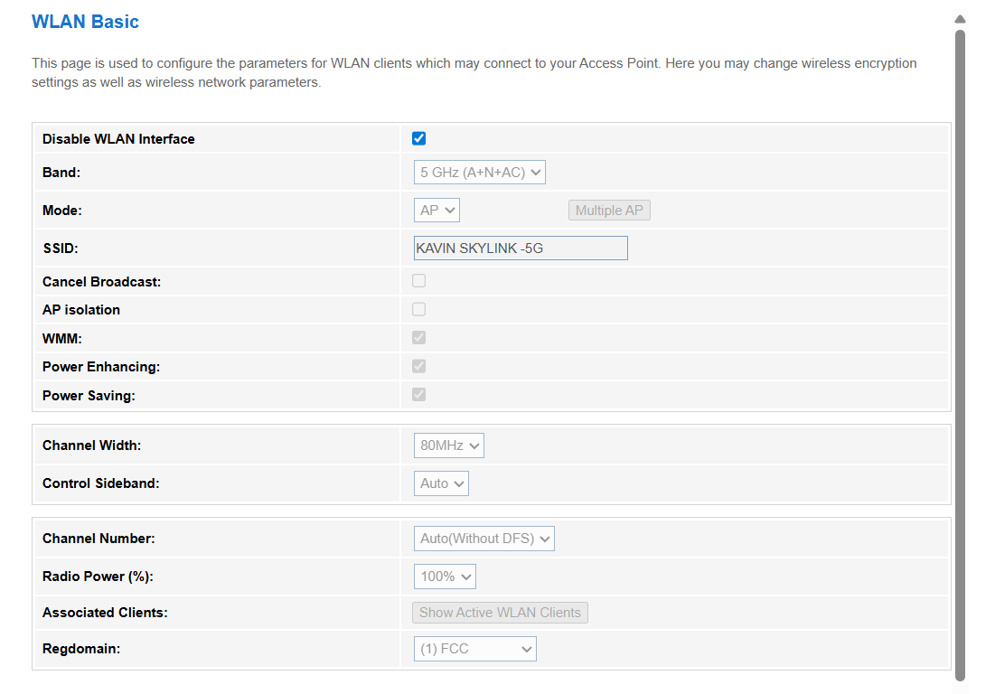
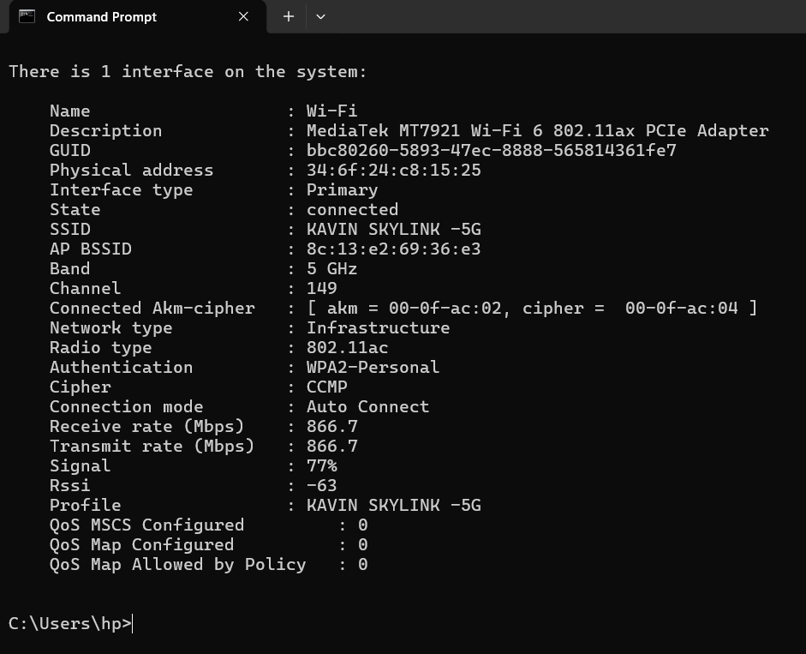

2.4GHz

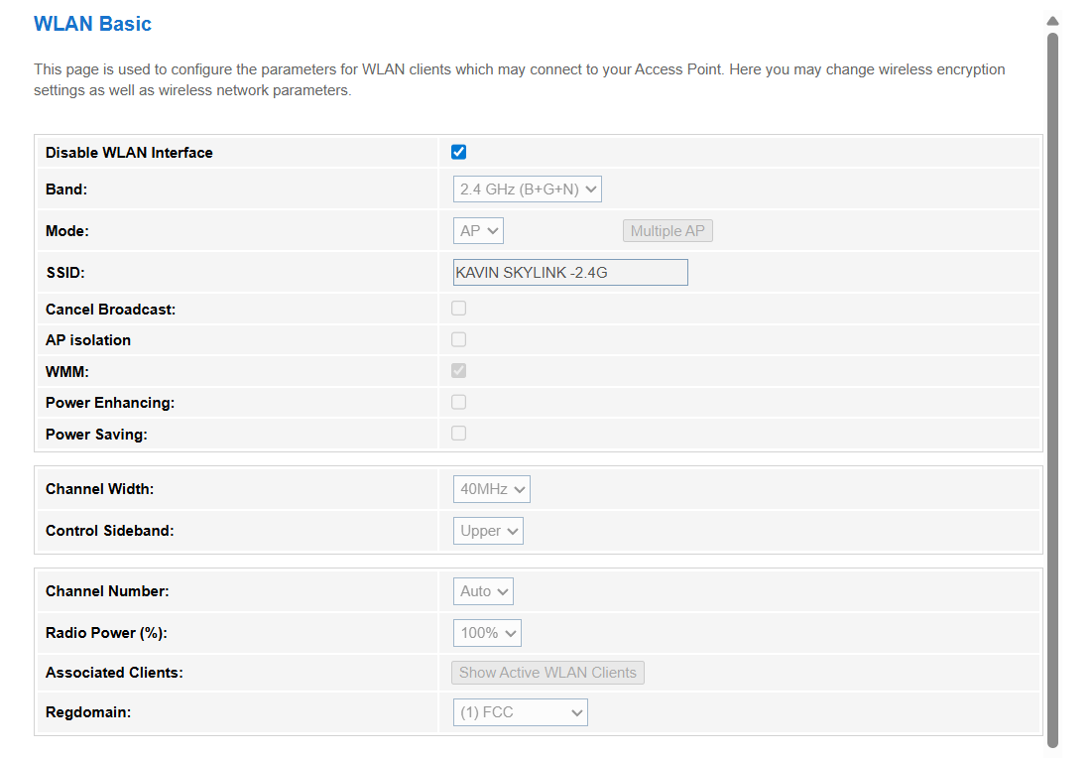
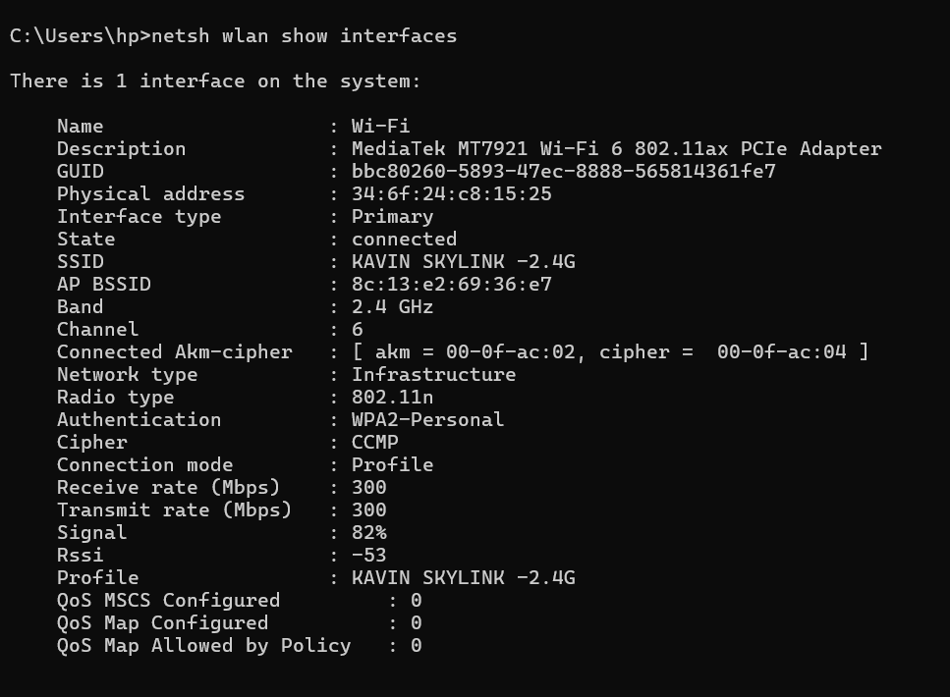

8. IEE - Institute of Electrical and Electronics Engineers
International organization that creates technical standards
Frequency bands
Modulation (OFDM, DSSS)
Data rates
Protocol rules
WFA - Wi-Fi Alliance
Organization that ensures devices work together properly
Ensures compatibility between brands
Gives simple names like:
Wi-Fi 4
Wi-Fi 5
Wi-Fi 6

9. Backhaul
The link between your router and the internet
Fiber
DSL
Cable
Cellular
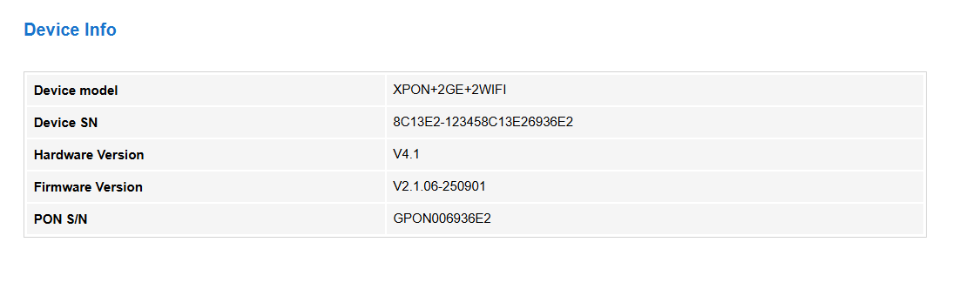

10. Wi-Fi topologies
Infrastructure Topology - Devices connect through a central Access Point (AP)
Home Wi-Fi, Offices, Colleges

Ad-hoc Topology (IBSS) - Devices connect directly to each other (no Access Point)
Temporary file sharing, Small group communication

Mesh Topology - Multiple access points connected together forming a mesh network
Large campuses, Smart homes

Point-to-Point (P2P) Topology - Direct connection between two locations using wireless link
Connecting two buildings

Point-to-Multipoint (P2MP) - One central AP connects to multiple remote devices
Wireless ISP (WISP), Rural internet distribution

